Organisation
Definition
People who are organised plan to do their best. They listen carefully and organise their time wisely. Being organised also means that they take care of their things.

What Organised People Look Like:
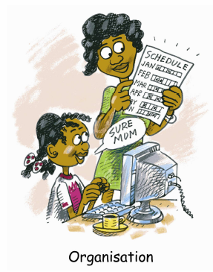
- They have all their school things ready.
- They bring home all the materials needed to do their homework.
- They take all the things they need to school.
- They make sure they listen and understand instructions before beginning a task.
- They get started on a task straight away.
- They keep a neat and tidy bag, desk or room.
- They plan enough time to complete tasks.
- They finish one task completely before beginning another.
- They know what is happening and when.
- They are aware of special events and dates at home and at school.
What To Say To Encourage Organised Behaviour:
- Being organised is helping you be successful.
- You planned well to get that done.
- You really focussed on getting that done on time.
- I bet it makes school easier when you have everything ready.
- You are really keeping your things clean and neat.
- I see you are planning your time so you don’t have to rush at the end.
- When you are prepared you do a great job.
- Well done, you have prepared to be successful.
What To Do To Help Be Organised
SETTING GOALS – Discussing goals whether they are personal or school based allow your child to plan for their own success and you can encourage and reward their progress.
PLANNING – Helping student to arrange when they will do the things they need to will allow them to be successful. This will also allow for a balance of time between sport, family, personal and homework commitments.

