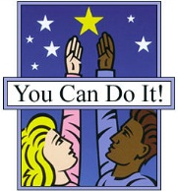
Getting Along
Definition
People who Get Along work and play together thoughtfully and cooperatively. They are friendly, tell the truth and care about others. People who Get Along want to make their community clean and safe. They are able to fix problems without arguing and fighting.

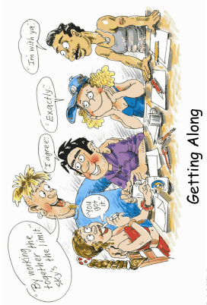
What People Who Are Getting Along Look Like:
- They share and take turns.
- They ask nicely to work or play with others.
- They listen to others when they talk.
- They ask for help when they need it.
- They do what their parents/carers ask them to do.
- They make an effort to care for others who are upset.
- They help others with their work.
- They include other people in activities that they are doing.
- They use manners and tell the truth.
- They care about the feelings of others.
- They deal with problems in a caring, considerate way.
What To Say To Encourage Getting Along Behaviour:
- You are a good listener.
- You are a helpful person.
- Sharing helps you be a good friend/brother/sister.
- You really work well with others, it must feel good.
- Solving problems without fighting shows you are really getting along.
- You think before you act, that is a wonderful skill.
- I love the way you think about other people’s feelings.
What To Do To Help With Getting Along
BE TOLLERANT OF OTHERS – Encourage children to be accepting of people who are “different”. Everyone is different, that is what makes us all special.

THINK FIRST – Discuss with children the possible ways they can react to a situation that upsets them and the consequences of each action so in future they can act in a way that helps everyone.

PLAY BY THE RULES – Encourage the following of important community, school and home rules. They are there to keep everyone safe, healthy and happy.

